Project Design Phase

Solution Architecture
Date | 06 July 2026
Team ID | __________
Project Name | UCab – Cab Booking System
Maximum Marks | 4 Marks

Solution Architecture
The UCab – Online Cab Booking System is designed using a three-tier architecture consisting of the Presentation Layer (Frontend), Application Layer (Backend), and Database Layer. The frontend uses React.js, HTML5, CSS3, Bootstrap, and JavaScript. The backend uses Node.js and Express.js. MongoDB Atlas is used as the cloud database with Mongoose ODM. JWT authentication and BCrypt password encryption provide secure access.
- Provide a secure and scalable online cab booking platform.
- Separate presentation, business logic, and database layers.
- Implement JWT authentication and role-based authorization.
- Automate cab booking, driver assignment, and fare calculation.
- Support future enhancements using REST APIs.

Example – Solution Architecture Diagram
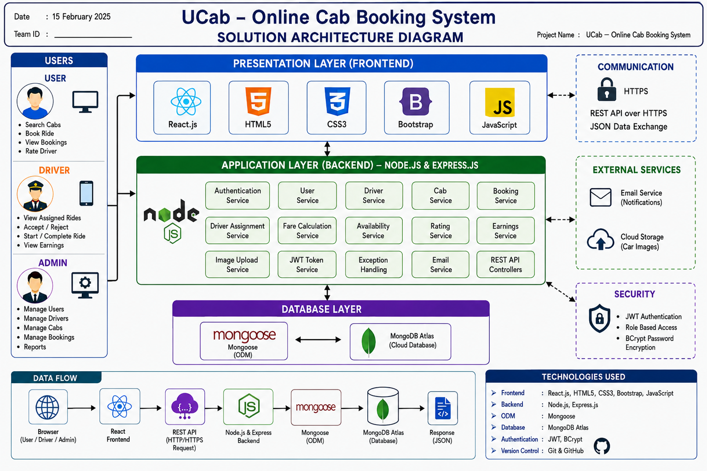

References
- https://react.dev/
- https://nodejs.org/
- https://expressjs.com/
- https://www.mongodb.com/atlas
- https://mongoosejs.com/
- https://jwt.io/
- https://getbootstrap.com/

